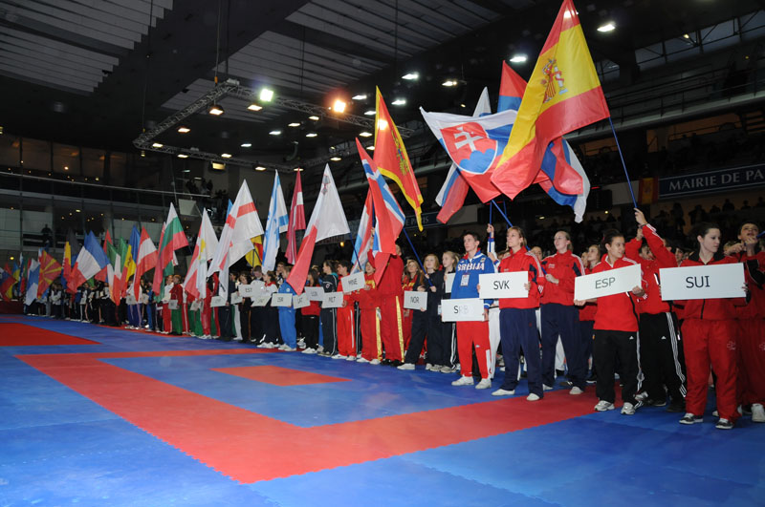

KARATE PREUNIVERSITAR-CUPA SHORIN RYU

Fişa de înscriere

Club: _____ __________________________________________________________________________

Oraşul: ______________________________________________________________________________

GSM-TEL: __________________________________________ WEB SITE:_______________________

Telefonul / fax / e-mail: ___________________________________________________________________

Nr. | Nume şi Prenume | Data Naşterii | Vârsta | Sex  B/F | Kyu  Dan | Kg/  Inaltime | Kata | Kumite | Kihon
1.
2.
3.
4.
5.
6.
7.
8.
9.
10.
11
12.
13.
14.
15.
16.
17.
18.
19.
20.

Semnătura

