ENTRY FORM 1ST JKA GASSHUKU
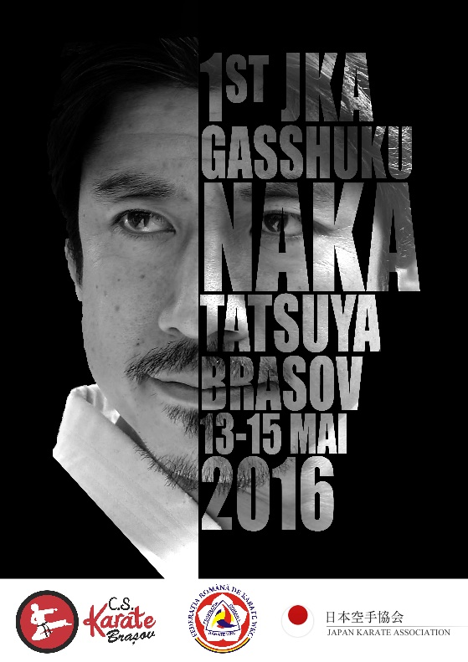
BRASOV – ROMANIA
NR | NAME | BELT RANK  10-5 KYU OR 4 KYU-DAN | T-SHIRT  (size) | SAYONARA PARTY  yes/no
1 | Example: Popescu Ion | 10-5 kyu | M size | Yes
2
3
4
5
6
7
8
9
10
11
12
13
14
15
16
17
CLUB NAME | TEL
COACH NAME | E-MAIL
CITY | COUNTRY

